Choosing My Project

All of my ideas:

* Inferno- 7 devils
* Pandora’s Box
* Herakles
* A to-do-list application (similar to Sorted3)
* Make a third person shooter - 3D
* Birds eye view stealth game (old metal gear solid)
* Smash bros/ gun mayhem (greekoroman mythology)
* Mortal kombat (greekoroman mythology)
* Annoying mario game with AI
* Metroidvania
* Survival metroidvania

Top 4 Ideas:

1. Inferno: stages/mission genre
2. Metroidvania genre
3. Birds eye view stealth game
4. Fighting genre game: mortal kombat or smash bros

My theme for my game will be **Greek Mythology** based on the story of **Hercules**

Metroidvania genre platformer game

3 or 5 different save files

Menus: settings (difficulty, sounds, screen-shake, vfx), inventory, and game progression, map, game screen

Different difficulty settings

A guide telling you what to do for easier difficulty, unguided for hard difficulty

10 bosses, 5 items, 5 gods to free (NPCs), multiple maps all linked

Specific special rooms: save, armoury, god, boss

Normal enemies spawn around the map except these rooms

Could use game development platforms like **Unity or Pygame** to develop my project into a high-level game, with more features

I could create **pixel art characters** (in different positions also) and environments to create my own customisation and visual look to the game

I will create the pixel art in the tools **Asperite or Adobe Illustrator**

I will create my TileMap on a free program called **Tiled**

stages/mission genre: have multiple levels in increasing difficulty each time. Each level is linear, and you move to the right defeating many small enemies and encountering traps until you reach a boss which you will need to defeat to progress to the next level. Inspiration from “Super Mario Bros.” Here I can build a storyline and a main objective in the game that the user is trying to achieve. This will be a 2D game.

Metroidvania genre: create one big world game sectioned up in different areas which can all be accessed through gateways and doors which need to be unlocked by playing the game. Game objectives need to be completed for new areas to be unlocked and for the user to progress in the game. AI controlled enemies will spawn periodically and each area will have a different ‘mini-boss’ and the final area there will be an end-game boss which completes the game and gives the user their score and their time taken to complete. This will be a 2D game inspired from earlier games such as “Metroid” and “Hollowknight”. I could add skills or items to be interactively used to help the player encounter the more challenging enemy types and a progression that the player can experience. I could also add a map feature where the player can open the map and see where in the map they are and what rooms have been explored and what other rooms and doors are still locked. I could also create multiple character designs for the player to choose from at the very start of the game.

Birds-eye view stealth game: this will have a birds-eye view on the game map and the player will need to navigate through the map around obstacles and avoid AI enemy detection, having to stealthily take out enemies to progress to the top of the level to progress to the next area. If detected, all the enemies will be alerted and be on high alert for the stage and be wearier of the player’s presence. Another 2D game inspired from old “Metal Gear Solid” games and new versions of them such as mobile games.

Combat platform game: a 2D game with a main platform and sub-platforms which the player will need to stay on to survive and fight off many AI enemies/ one more difficult enemy. The game could also be adapted so that there is no platform, and the objective of the game would be to survive and defeat the enemies to progress to the next level. With mini bosses at each stage and a main boss relating to the game’s storyline. character/ weapon/ map selection.

**Extra**:

In each game the player’s character would have weapons such as swords and shields to defeat the enemies and possibly be able to acquire ‘godly powers’ by completing previous mini-bosses which could be used to deal special damage.

I have chosen to make a game for my A-Level project using AI controlled enemies to increase the complexity of my project. I am confident with my programming skills and knowledge; although I am not the best, I have the skills to make a high-level project. I am very confident in my Python programming knowledge including multiple libraries that extend the functionality of Python in my project.

I will most likely use the Pygame library to make the main GUI of my game and use other libraries such as Tkinter and other languages such as HTML, CCS and JavaScript to make forms if needed in my final project. I will be using the mySQL library on Python for the back-end development and data handling to be able to reliably manipulate user and game data.

I will be using Python’s ability and capability of high-level object-orientated programming to structure and design my project as this makes the code a higher level, more organised, and more efficient.

I am looking forward to creating a fully functional game with multiple stages and increasing difficulty levels which could be challenging to the average user and enjoyable to the average video game user as they are my target audience and main stakeholders in this project. Although making a fully functional game with no ‘bugs’ or issues could be challenging for me as I have never created one from scratch before, this will be a fun learning experience and I

will document all the problems I will encounter and my problem-solving techniques and methodologies to fix them.

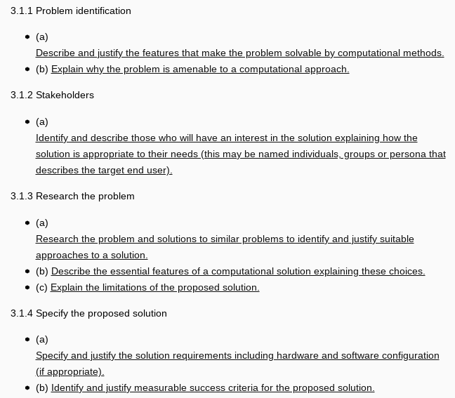

New features:

* Character customisation
* Difficulty settings
* Different enemy types
* Backtracking allowed by unlocked by attained items, to unlock previously locked pathways to other rooms
* Save points
* Multiple save files
* Skill selection
* Mini-bosses: earning skills and key items
* Two different environments [light/dark worlds]
* Dark: caves, tartarus
* Need to switch between worlds to unlock new abilities and items to continue
* Upgrades and abilities

Story:

* Hades unleashes titans and monsters from Tartarus to the earth
* Hercules gets stripped from all his powers
* 12 labours = upgrades
* Zeus telepathy as guide
* Free different gods to advance to next stage; Hades imprisons them at the start
* Gods guarded by monsters
* All the monsters Hercules killed are revived by Hades and now guard the gods
* Weapons: sword and bow

1. Nameanian Lion – hide = more health (Claws)
2. Diomedes’ mares – guards a god - Hephaestus (Sword)
3. Stymphalian birds – (Talons)
4. Cretean Bull – guards a god - Athena (bow and arrow)
5. Belt of Hippolyta – more swords strength (Belt)
6. Erymanthian Boar – guards a god - Aries
7. Ceryneian hind – super speed (Golden Horns)
8. Cattle of Geryon and two headed dog – guards a god - Hermes
9. Lernaean Hydra - poisonous arrows (Unlocks Venom Ability)
10. Cerberus – final boss – guards Zeus - granted immortality